Kale Balls

**Kale Ball Ingredients:**  
• 8 cups chopped raw kale (remove large tough stems, but keep small tender ones) - I did use my food processor for this step to save me time even though I love to chop, chop, chop with my chef's knife  
• 3 eggs  
• 1 teaspoon dried Italian herbs  
• 1/2 teaspoon dried garlic powder (more if your family really likes garlic, like mine)  
• 1/2 teaspoon low sodium tamari  
• 1-2 Tablespoons olive oil  
• 1/2 cup freshly grated Parmesan cheese  
• 1 cup whole wheat bread crumbs  
• 1/4 cup ground flaxseeds  
  
[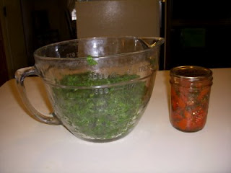](http://3.bp.blogspot.com/_J4FM8jynDEc/SUVP3_co4eI/AAAAAAAAAh4/3l_6fjoK1Rg/s1600-h/WiltedKale4cupsbrschetta.JPG)Steam the chopped raw kale (I used a steamer basket) for just a few minutes to wilt but still maintain bright green color. The 8 cups reduced to 4 cups after steaming (4 cups pictured in this photo along with a jar of the Bruschetta-in-a-jar recipe). Save the water in the bottom of the pan in your freezer for future soup broth.  
  
Lightly beat eggs in a large bowl, then add all other ingredients (except kale) and mix together. Finally add in kale and mix well. Don't be afraid to use your hands at this step to evenly mix everything!  
  
[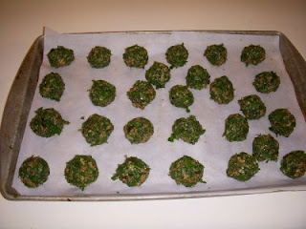](http://3.bp.blogspot.com/_J4FM8jynDEc/SUVP4KjP8mI/AAAAAAAAAiA/9uy9UIE-jUs/s1600-h/Kaleballsreadytobake.JPG)Line one cookie sheet with parchment paper. Using a teaspoon and your hands, make 25-30 kale balls. I made 28 balls, each about one inch in diameter or about the size of a walnut in the shell.  
  
Bake at 350 for 15-20 minutes until they just start to brown. The bottoms of the balls were brown after 20 minutes in my oven, were holding together and rolling around the cookie sheet, plus well heated throughout, so I called them done.